Taboo: "Voodoo"
According to Wade Davis, Voodoo is a legitimate religion with Priestesses and Priests-
Yvonne Sherro says it is a religion of mysteries
*personal access to the spirit world by everyday adherents
*beginnings are found in West Africa where it probably started with combinations of ancestor worship and animistic traditional spirituality.
*Involved with healing and prosperity.
*Benin, Africa – Voodoo is the official religion 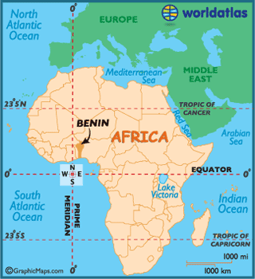 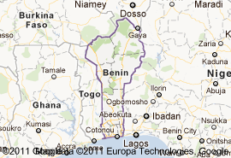
Voodoo means "spirit" in the Benin language, Fan.
Case #1: Allada, Benin
The head priest's daughter has been called by the spirit world. He wanted for his daughter to get an education and have a good life ahead of her, so he denied the spirits. She did poorly in school, so finally he decided he would respect the spirit and allow her to be called. This process has both allure and trepidation because it is believed [and shown] that the young teenager will be killed by the spirit. She is dead to her community for 3 days. She is then resurrected on the 3rd day and reborn as a new person. The whole community helps in the ritual to bring her back. Priestesses lay their open palms on her body as an invitation for her spirit to return. A live chicken is also rubbed against her body to invite the spirit. She awakens knowing a new language and new dances that she has learned with the spirits.
Case #2: coast of Benin
Akpla – War deity: demands blood of an adherent, a fisherman, who goes into trance and experiences spirit possession. He is wounded while the spirit is inside him and cannot talk about the wound because that would bring bad luck.

